**Manual Testing for Final Project – Week 3**

* Running the local host should take you to the home page of the website.



* Clicking on “How it Works” or “Team” should take you to the respective sections.

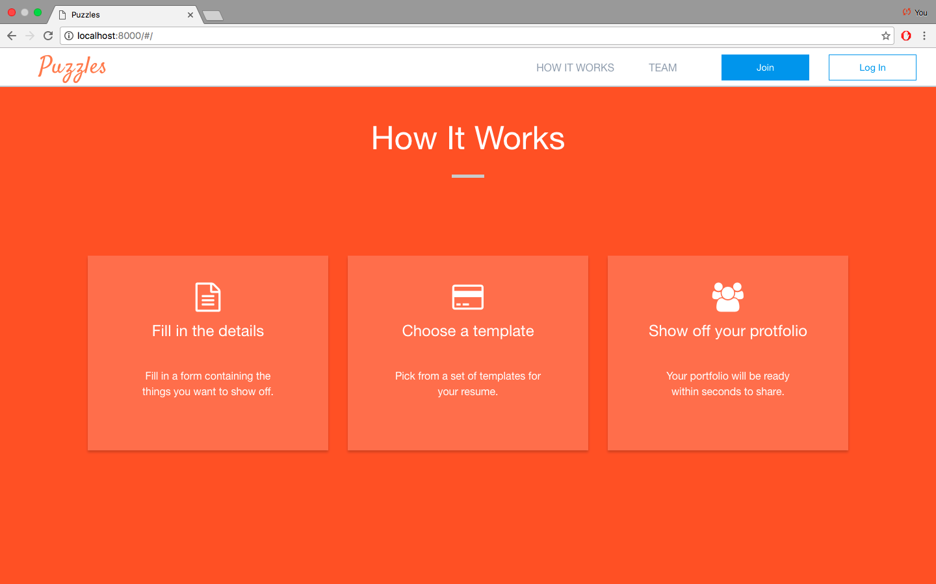

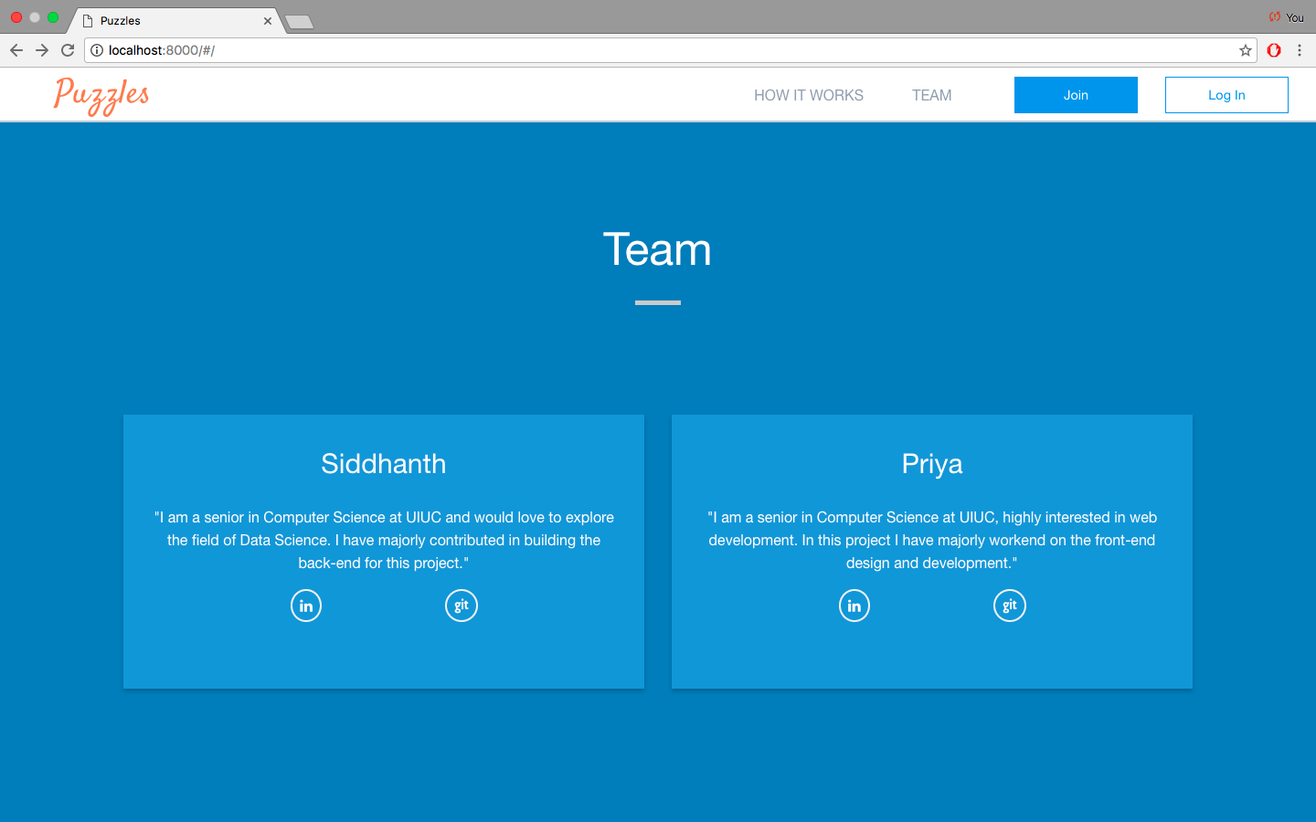

* Clicking on “Get a look” should currently take you to the form to start entering your profile details.

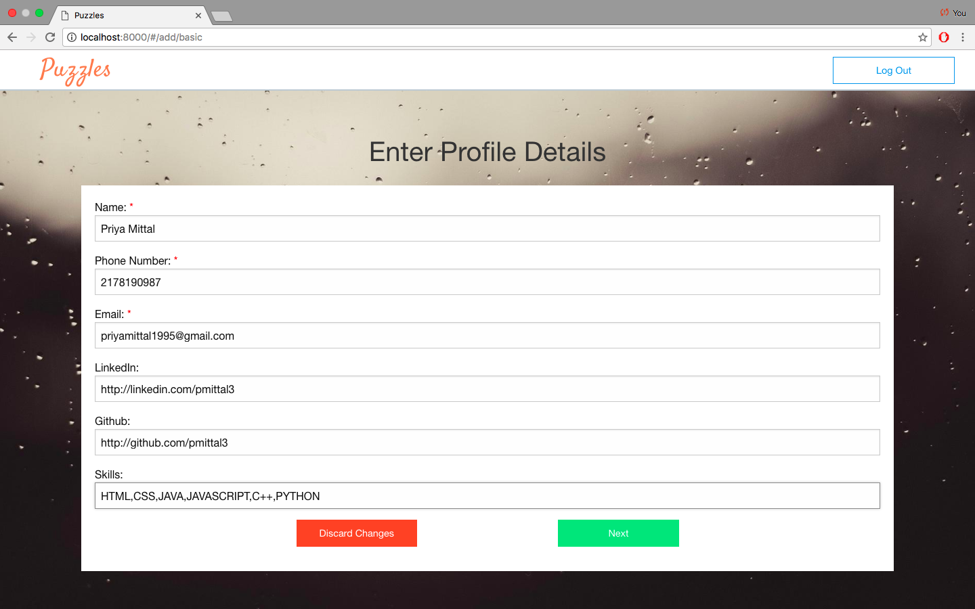

* Clicking on the next button should take you the form that fills up the most recent education.

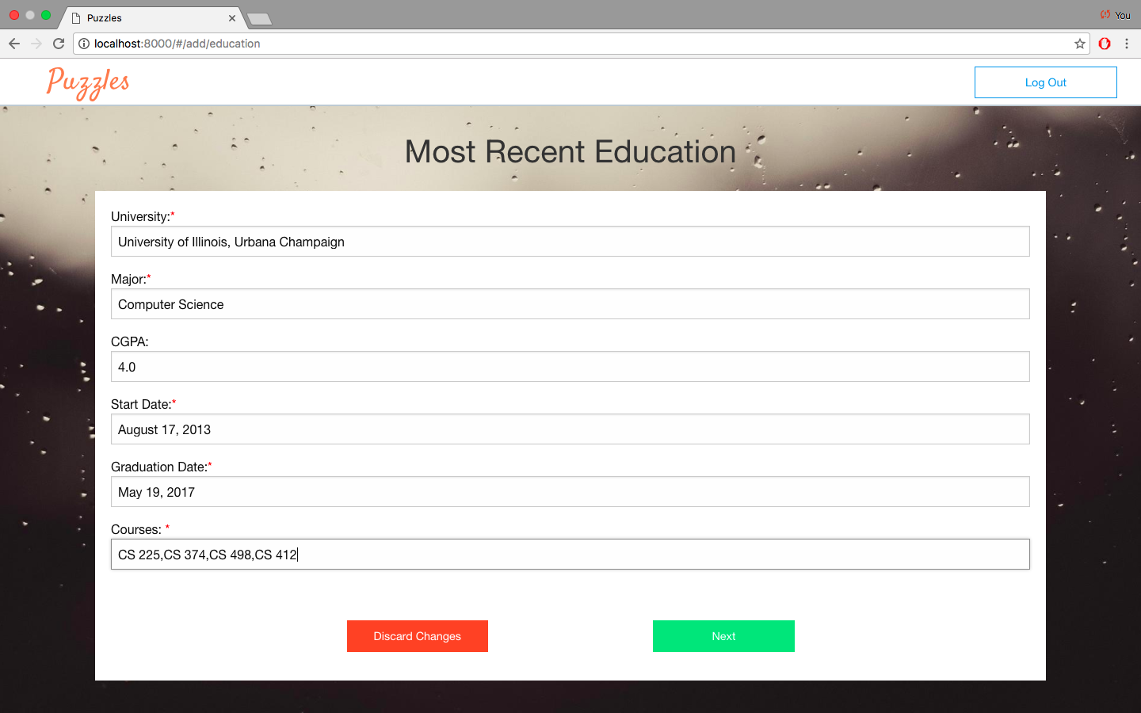

* Clicking on next should now take you to the page where you can enter your internship/work experience details.

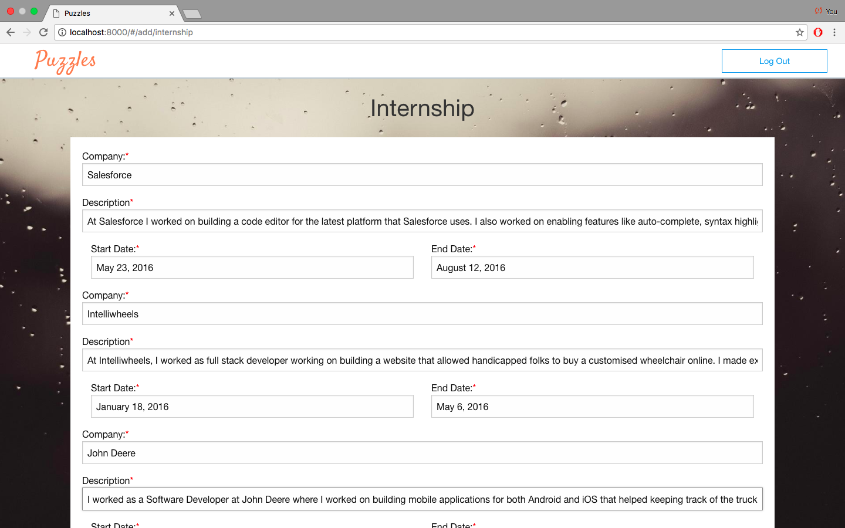

* Clicking on next should take me to the forma page that allows me to submit any projects that I have worked on.

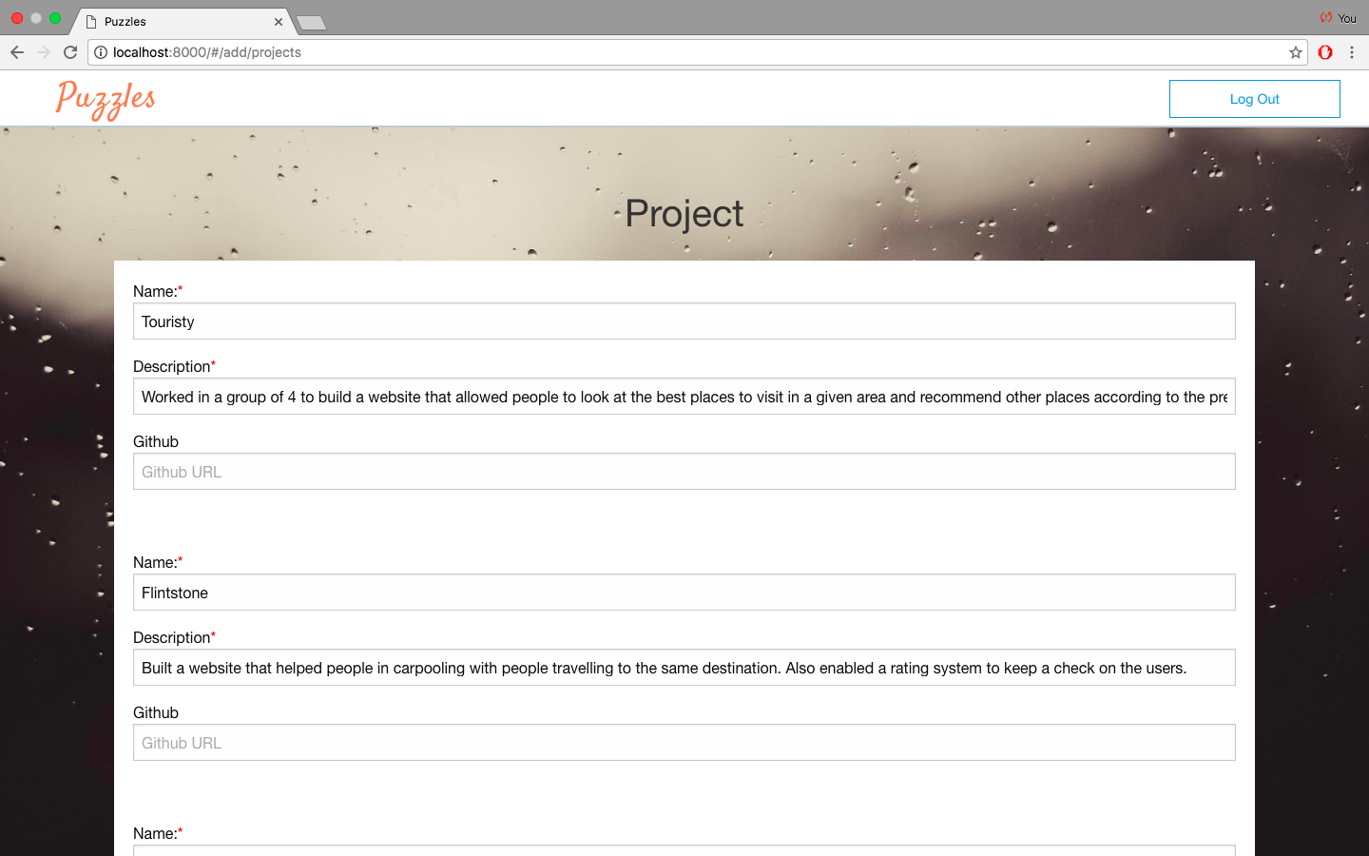

* Clicking on submit should give you a success message.
* On the portfolio page, clicking on Puzzles on the top left cornet should take you back to the home page.



* On the portfolio page, clicking on “Home”, “About me”, “Experience”, “Projects” should take you to the respective sections and should have the information that you filled in.



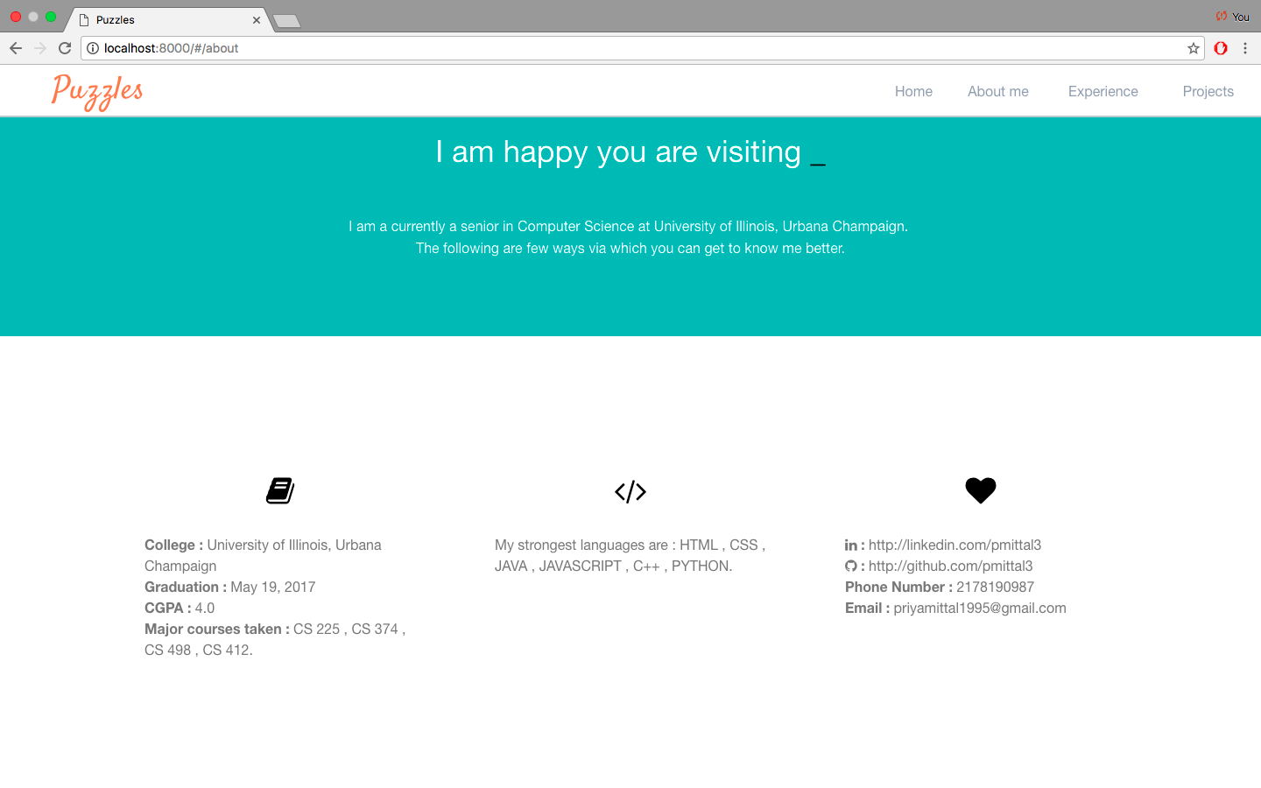



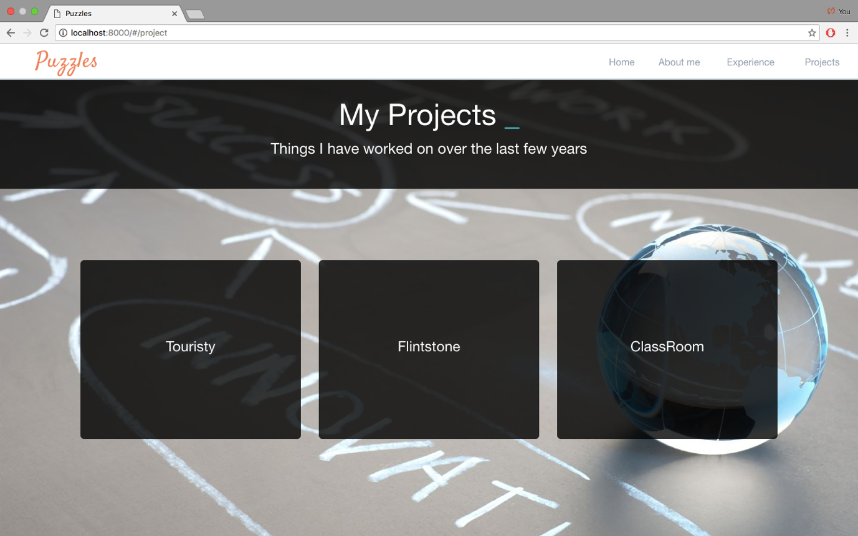

* On the portfolio page, clicking on “Get to know me” should take you to the “About me” page.



* Hovering on the project names should give you the description of each project.



* Refreshing the page should generate a different background for the work experience section.



* Dynamic Portfolio Page

If only one information is present



If two information is present



* Login

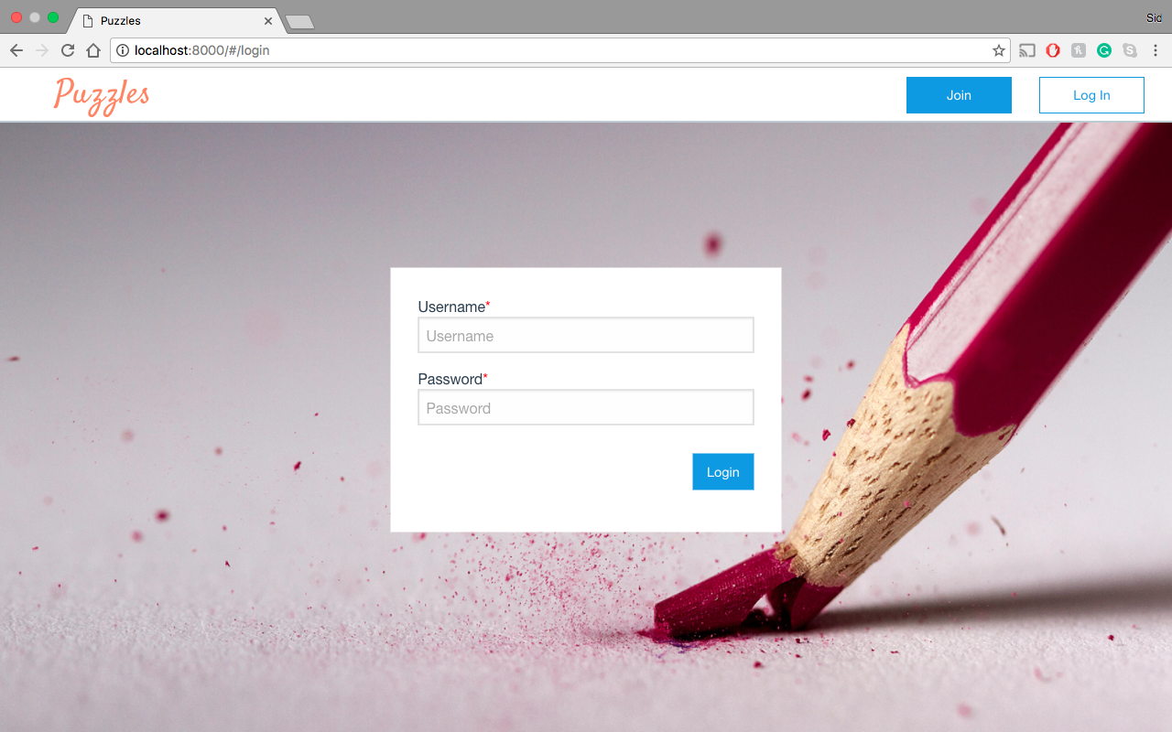

If username or password is incorrect:

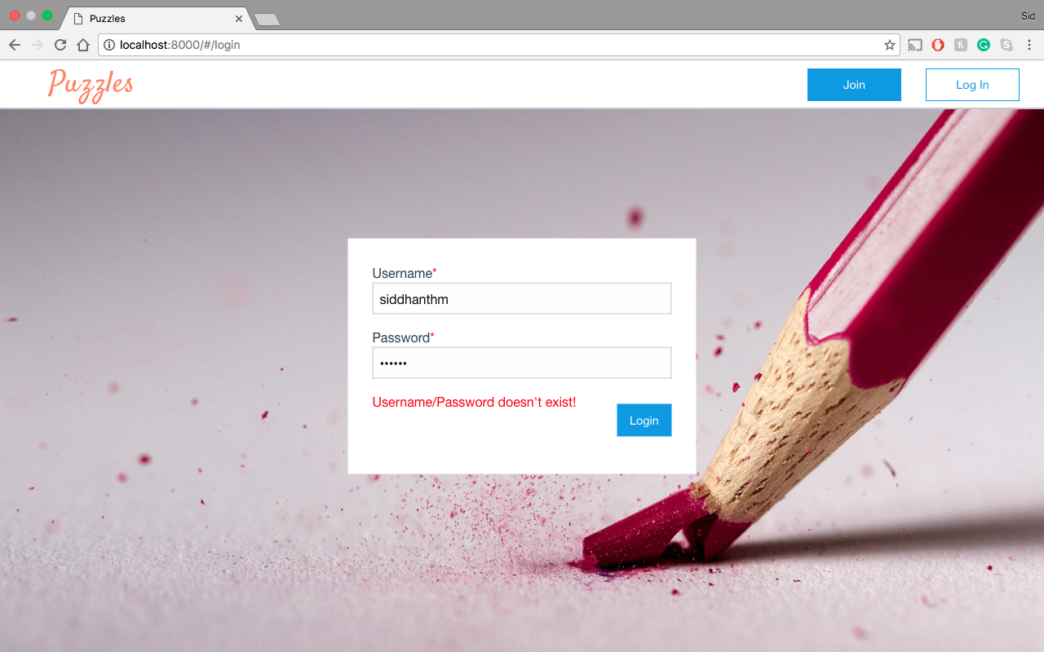

If the information is correct:

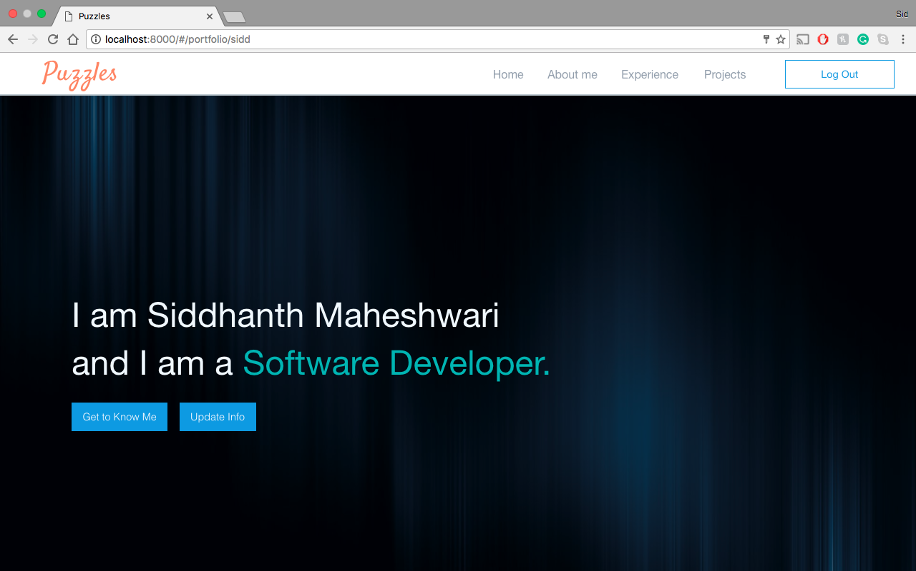

Steps:

1. Go the login page <http://localhost:8000/#/login>.
2. Enter the username and password.
3. If the username or password is wrong, then the error should show up else it should take it to your portfolio page

* Getting all the users

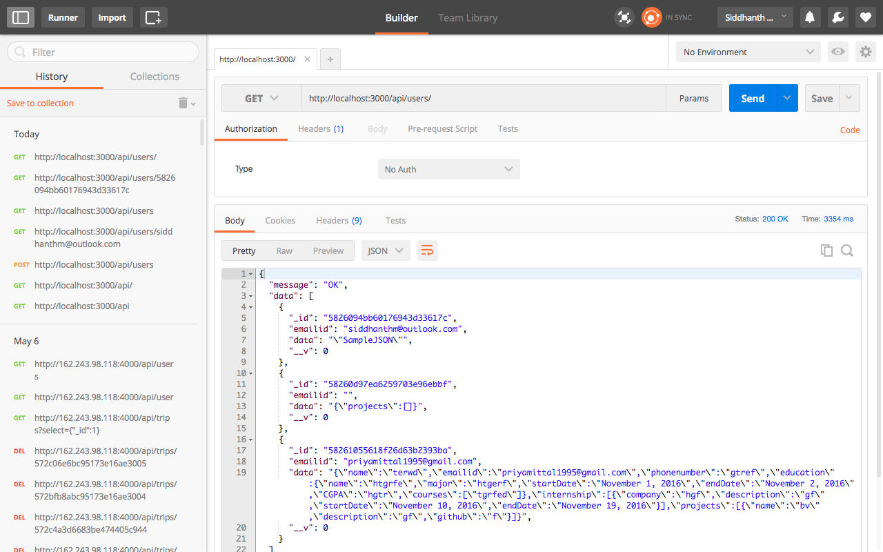

Steps:

1. Open Postman
2. Send the GET request to <http://localhost:3000/api/users/>
3. Ensure that all users are present.

* Getting a particular user

If user is present

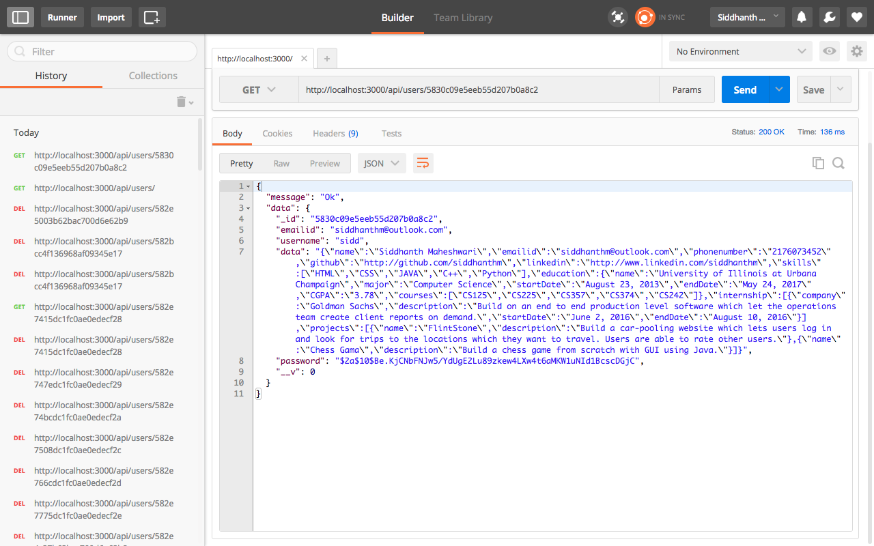

If the user is not present

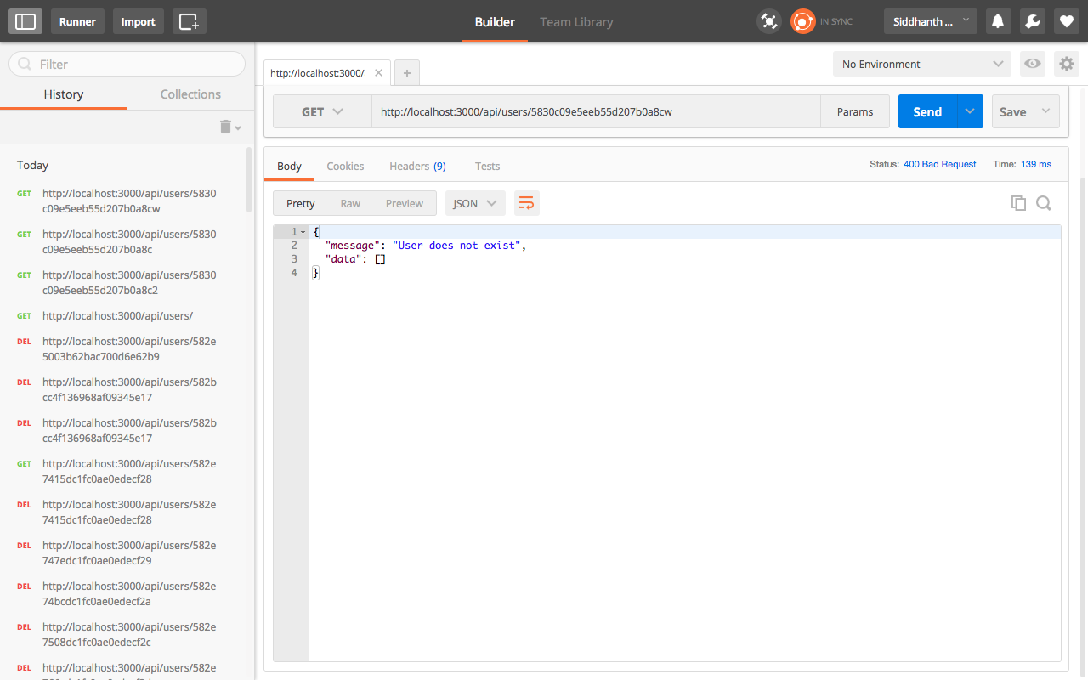

Steps:

1. Open Postman
2. Send the GET request to <http://localhost:3000/api/users/><userid>
3. Ensure that the user information is present if the user is present and user doesn’t exist if the user is not present.